# PRESS KIT

• • •

Contents

* Biography
* Press & Performances
* Links
* Social Media

**NIKKI BROOKS**

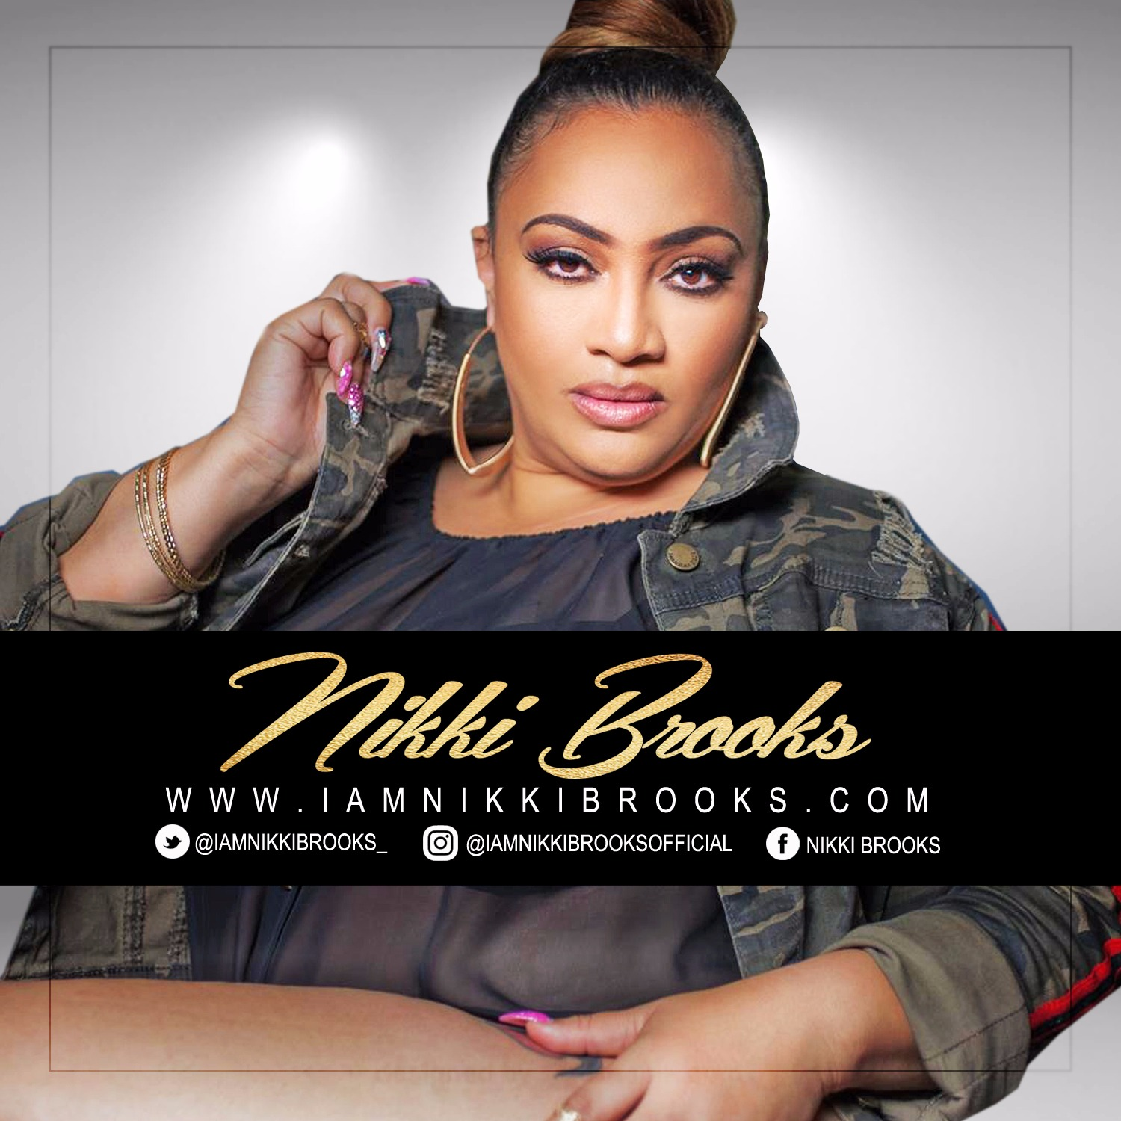

**NIKKI BROOKS**

# Biography

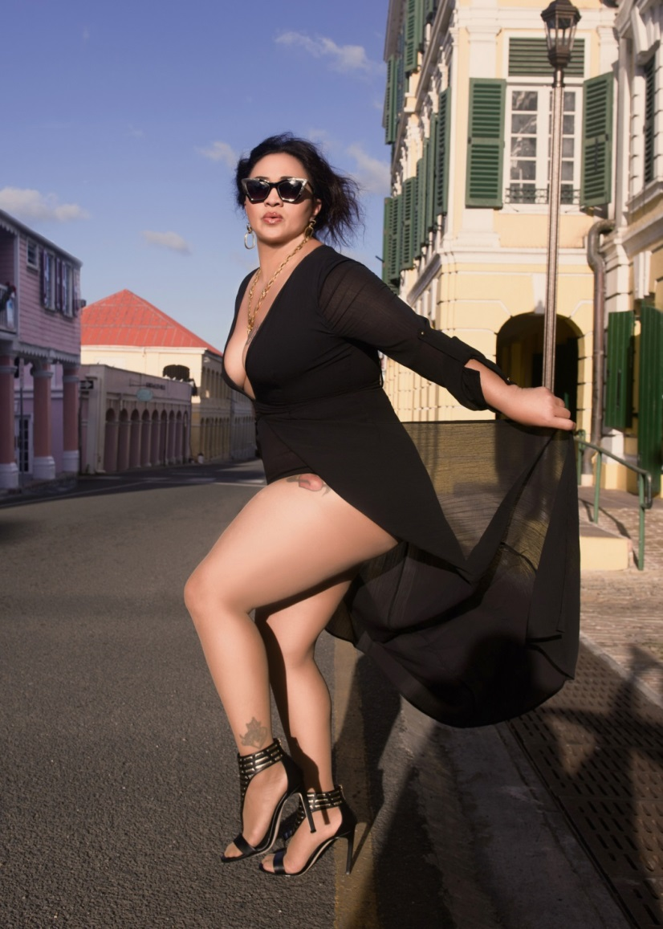Born on the island of St Croix USVI, Nikki Brooks initially gained huge notoriety as the infamous female voice, belting vocals for big bands throughout the Caribbean. With her pure talent and high energy performances, she is rapidly growing momentum in the Soca industry. She has received astounding support from her ever expanding fan-base securing her favor as an international cultural ambassador.

Nikki has provided vocals for top bands including St. Thomas’ Imagination Brass, St. Croix’s Vio International Band and the legendary DC based Image Band. She holds the honorable distinction of being crowned the first ever female Calypso Monarch capturing that title in her homeland of St. Croix.

In April 2016 she released her first solo debut album titled “Know Me Now” which includes 7 tracks currently available on iTunes, Amazon Music & CD Baby. The project’s 1st single “Play Me Like Pan”, topped Tempo network’s Cross Caribbean Countdown for 12 consecutive weeks at the number #2 position before hitting #1. Her 2nd single “Know Me Now” is currently in heavy rotation on radios throughout the Caribbean, London and Amsterdam. Its music video was released on Nikki’s Facebook fan page on July 4th to an overwhelming response, amassing over 350K views in just 2 weeks. The outpouring support has only motivated Nikki who plans to take her flavor to another level.

Nikki’s sassy voice on Soca and Calypso sounds stemming from her US Virgin Islands and Anguillan roots creates a uniquely enticing allure for lovers of the genre globally. Nikki’s “Know Me Now” album has reinvented the Soca sound and reintroduces the genre on a mainstream level via her new signature “Soca Pop” sound.

**NIKKI BROOKS**

Summer of 2016 Nikki headlined at NYC’s legendary BB Kings for Tempo Networks’ Tempo Turns 10 Caribbean Rocks NYC Awards where she performed amongst Soca Legend Mighty Sparrow, Romain Virgo, R. City and some of the Caribbean’s biggest talents. She performed at Tortola’s 2016 Carnival festivities and headlined NY West Indian Carnival Labor Day performances at the Virgin Islands’ annual Cultural Fest at Jackie Robinson Park in Harlem and Brass Fest at Brooklyn Museum. She will continued promotion of her “Know Me Now” album via tour stops throughout the Caribbean and US this fall. The magnitude of Nikki’s album and unveiling of her sizzling hot “Know Me Now” video is rejuvenating Soca lovers and captivating a whole new audience all at once.

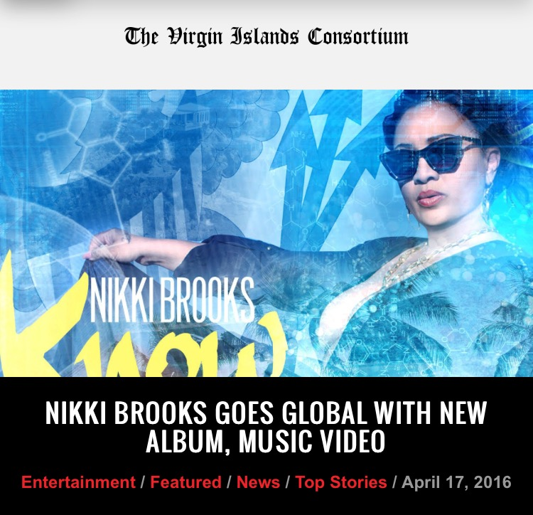

**PRESS & PERFORMANCES**

Press and Performances

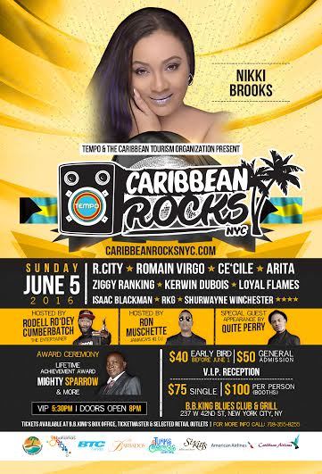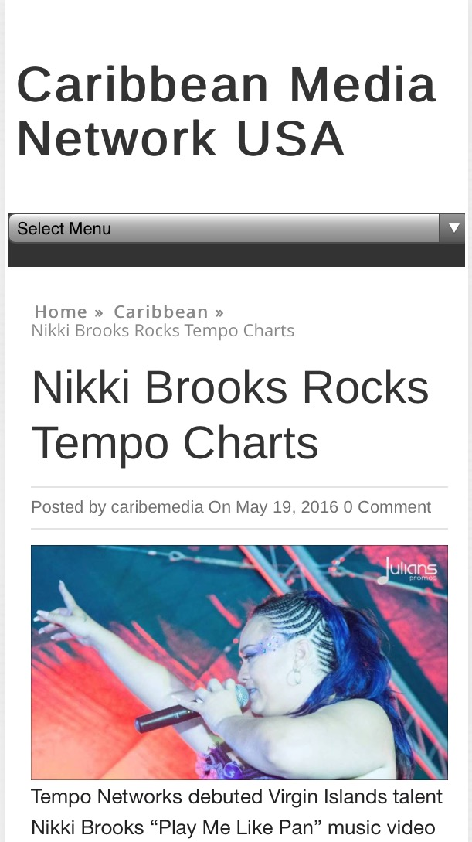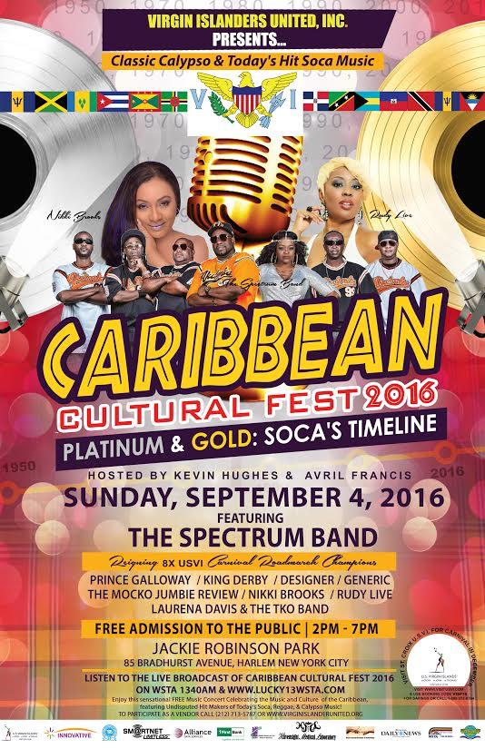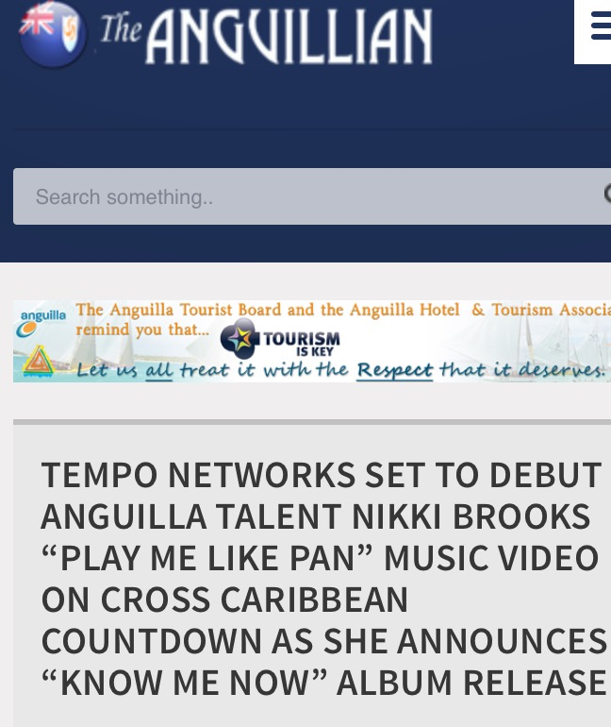

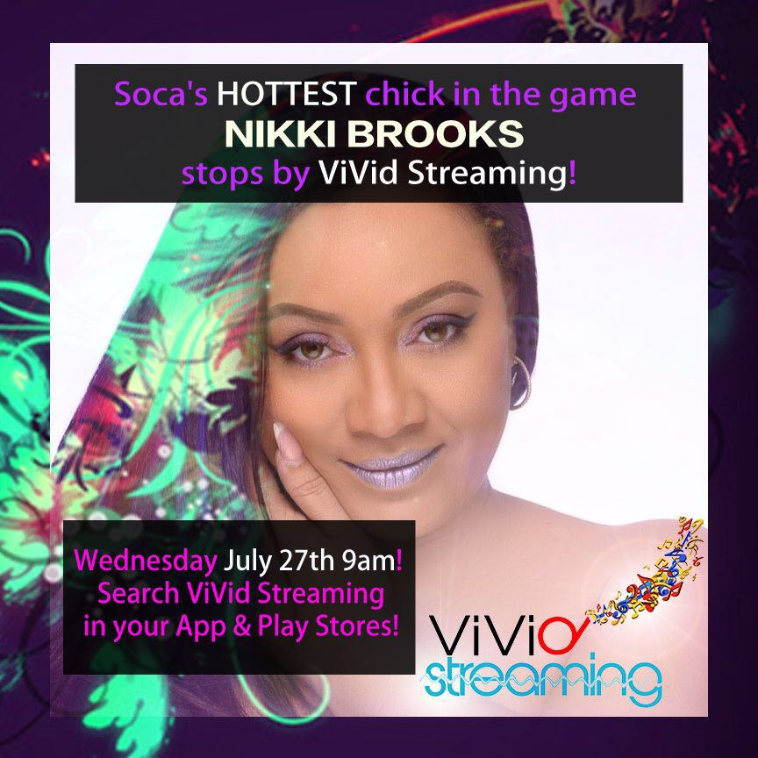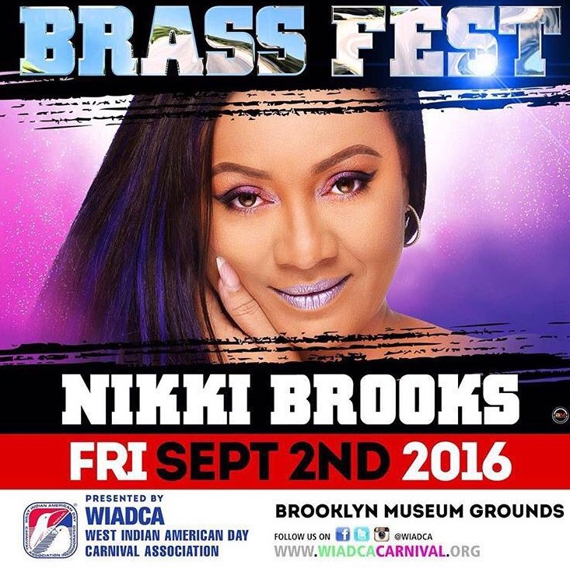

“I am Nikki Brooks”

<https://www.facebook.com/Lynda.BrooksRey/posts/10155070336524697/>

“Know me Now” Music Video

<https://www.facebook.com/948453315190258/videos/1057114560990799/>

“Play meh like Pan” Music Video-

<https://www.facebook.com/948453315190258/videos/1015265121842410/>

# Links

• • •

Interview for KRIBBEAN:

<https://reviews.kribbean.com/interview-with-nikki-brooks-cb325343bf8c#.7lg0havs8>

Soundcloud Playlist :

<https://soundcloud.com/kribbean/sets/nikki-brooks/s-40ccq>

Fan Page-

<https://www.facebook.com/I-Am-Nikki-Brooks-948453315190258/>

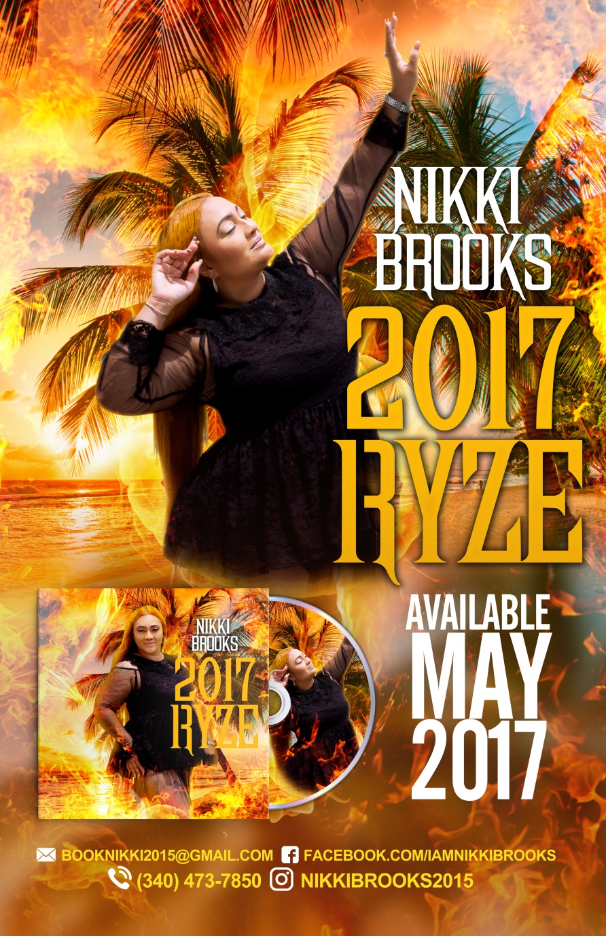“Ryze” 2017

In May 2017 Nikki plans to release her second album “Ryze”; a musical manifestation of her ability to rise above obstacles.

For her newest album, Nikki entrusted the help of Trinidadian producer Dnyce; real name David Pereira, who’s Caribbean and International sound blends several genres into a creative melting pot that perfectly complements Nikki’s unique sound and musical vision.

His work on the project has been a great asset in creating mesmerizing pop melodies with savory Caribbean roots.

The official release on May 2017 was a great success and boasts tracks such as “Africa Inside ah Meh” and “O Nah Nah”; music that she believes captures the Caribbean identity.

She highly anticipates this New Album called Wild and Free to show her adversity in the World scene.

**NIKKI BROOKS**

**Concept and Vision- 2018/2019**

Nikki believes that we are one Caribbean! To her that

means that we are family unified by our similar culture,

energy, and passion. Her music vocalizes her great love

and connection to One Love in One Caribbean!

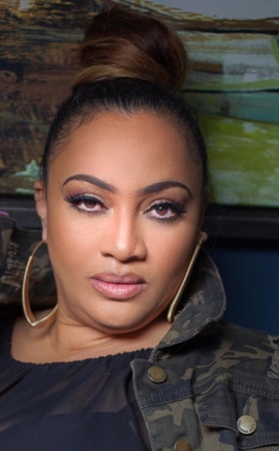

**Mission-**

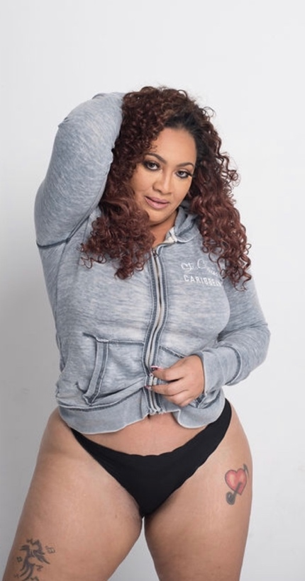To take the music and culture internationally!!

Contact Information:

